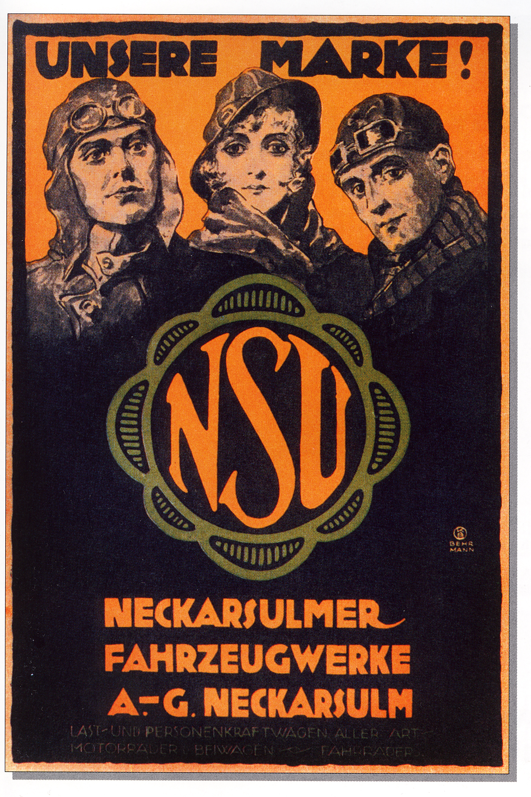
Invitation to tender

4th NSU meeting for motorcycles
(until construction year 1945)

The MC Spremberg e. V.
Calls up a meeting with NSU motorcycles

9th June to 11h June 2017
At the club premises of MC Spremberg e. V., Spremberg-Trattendorf, Kraftwerkstraße 41c

Provisional schedule

Friday 9th June 2017
- Arrival (from approx. 2 pm)
- First expert conversation among participant with grilled food and draft beer.

Saturday 10th June 2017
- 7:30 am breakfast
- 9:30 am ride to “Spreewald” (The women of the motorcyclists can take part this ride with a vintage bus)
- approx. 11.00 am boat trip in the “Spreewald” for approx. 1.5 hrs
- 12:30 pm lunch
- 2 pm visiting the “Spreewaldhof Falkenbach“ (coffee time )
- 17:00 am exhibition of all vehicles and a small classic car market in Spremberg / Trattendorf
(Everyone can bring and sell or exchange some of their „precious scrap“ individually.)
- 7 pm diner
- pleasant get together at the club premises, expert conservation

Sunday 11th June 2017
- 08:30 am breakfast afterwards good trip home

Head of the event
MC Spremberg

